Assignment #2

**Exercise 2.1 – Building the Server Virtual Machine**

Step 16: Take a FULL SCREEN SHOT of the *Ready to Create Virtual Machine* window showing the virtual machine settings and paste it into the worksheet document where indicated

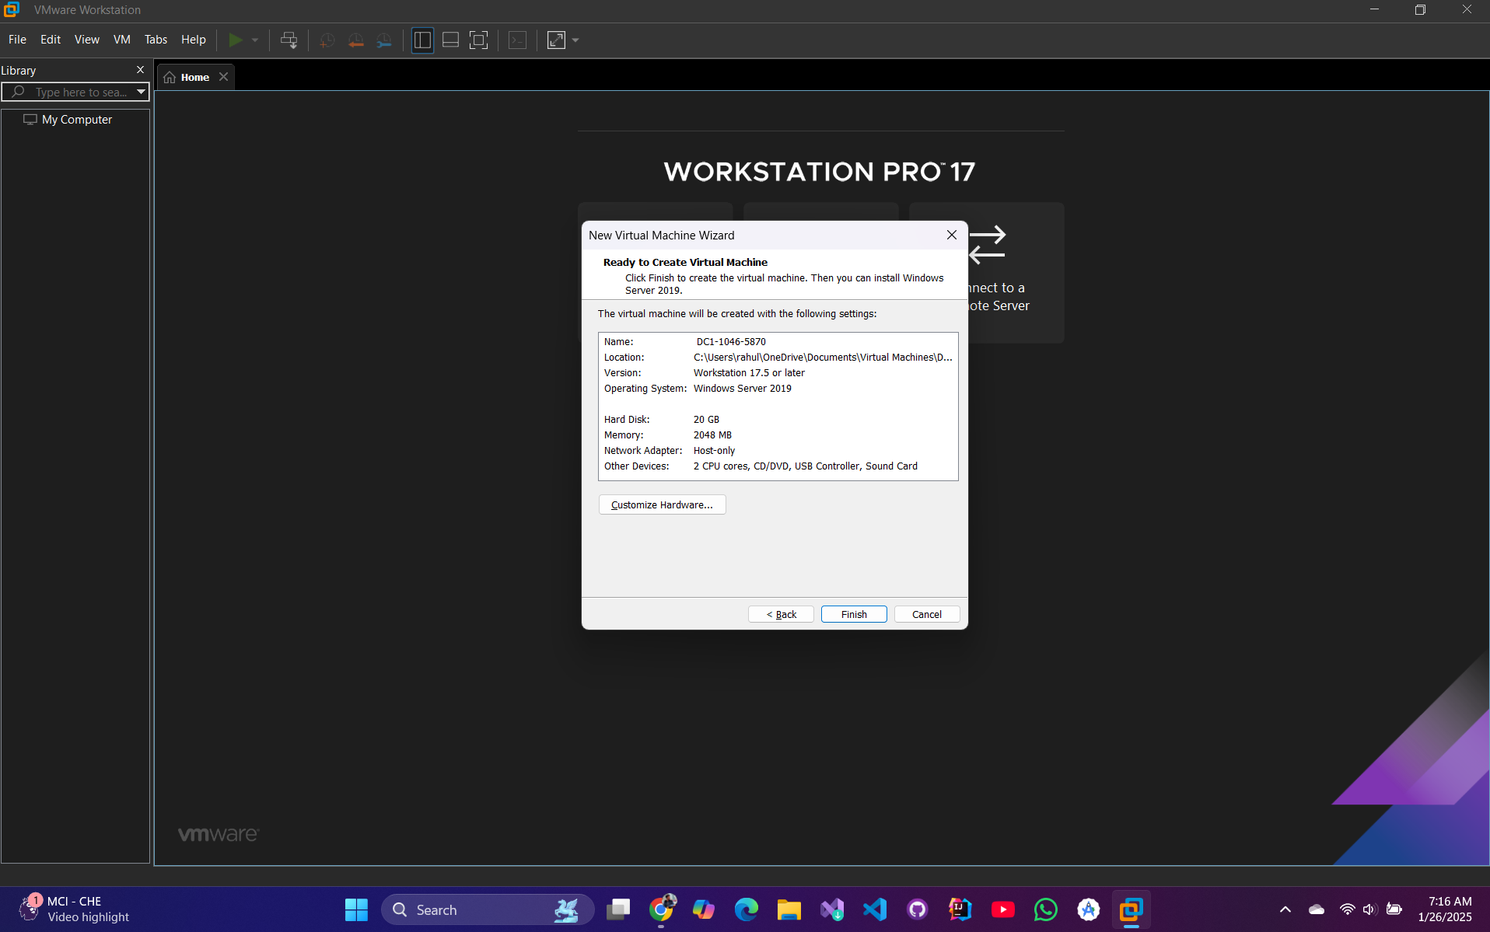

**Exercise 2.2 – Building the Client Virtual Machine**

Step 24: Take a FULL SCREEN SHOT of the *Ready to Create Virtual Machine* window showing the virtual machine settings and paste it into the Word document as per assignment instructions.

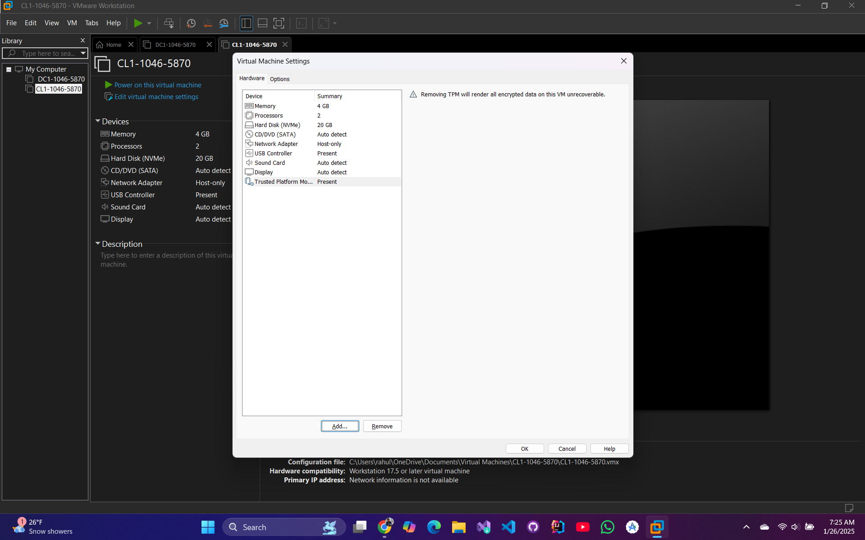

**Exercise 2.3 – Downloading requisite software**

Step 17: Take a FULL SCREEN SHOT of the File Manager folder that displays the downloaded files on your computer and paste it into the Word document as per assignment instructions.

